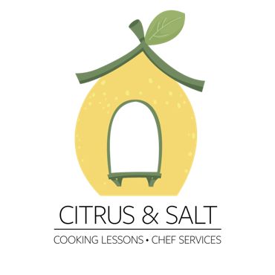

italian Menu

olive oil crackers
hand rolled crackers seasoned with black pepper

fresh pesto
classic basil sauce with parmesan and olive oil

Arugula salad
Topped with fried feta, pears, and pecans

Ravioli with handmade ricotta
fresh pasta stuffed with ricotta cheese and herbs

Salmon Alfredo Sauce
Made with white wine, cream, and oregano

Price list:
Group class ( when available): 250nis/person
Private: 490nis
Private Couple:690nis

