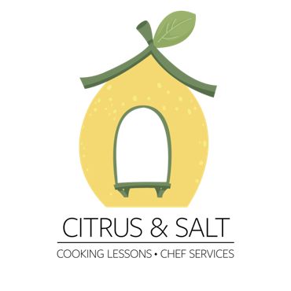

Thai Menu

Choose One:

Dumplings
Beef-lemongrass filling with fish sauce

Rice paper Fresh rolls with peanut sauce
Filled with noodles , egg, and herbs

Choose Three:

Pad thai
Rice noodles with tamarind and fish sauce

Papaya salad
Green papaya with peanuts, green beans and tomatoes

Handmade curry
Crushed Thai spices with a coconut-chicken base
Served with jasmine rice

Mango sticky rice (in season)
fresh mango with thai sticky rice and coconut cream

Price list:
Individual joining a group class: 250nis/person
Private: 490nis
Private couple:690nis

